🚀 CloudPulse
Autonomous Infrastructure Intelligence + Control Platform
This architecture includes:
- Start/Stop control
- Intelligence engine
- Optional automation
- Cost visibility
- Logging

High-Level Architecture Diagram (Conceptual)
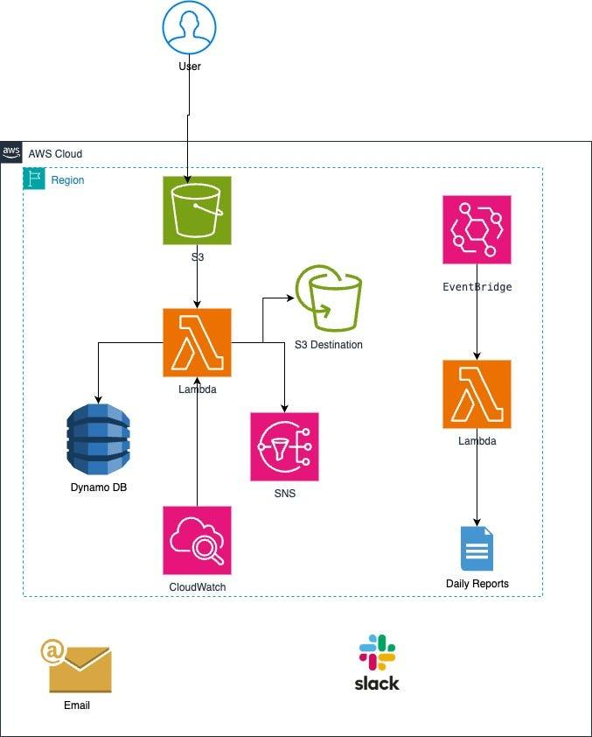
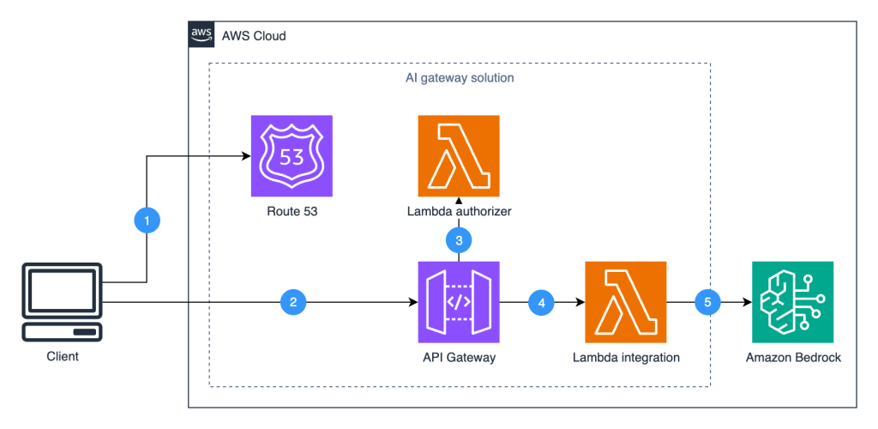


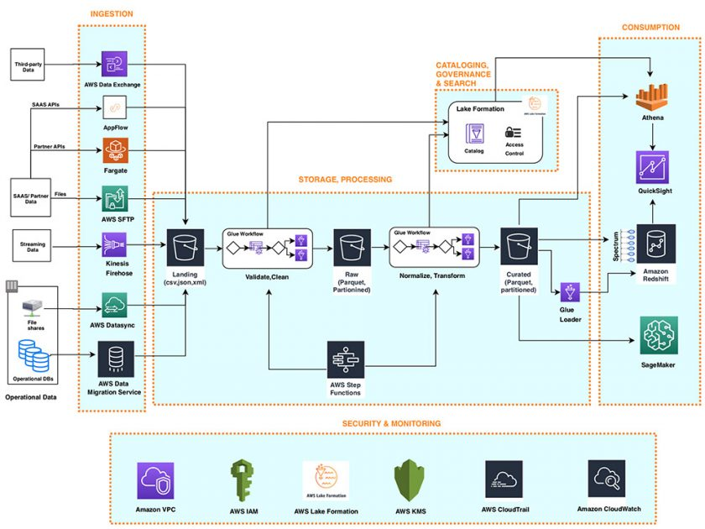

🔷 1️⃣ Presentation Layer (Frontend)

🔹 Amazon S3
- Hosts static website (HTML, CSS, JS)

🔹 Amazon CloudFront
- HTTPS
- Secure global delivery
(Optional but professional)

🔷 2️⃣ API Layer (Secure Gateway)

🔹 Amazon API Gateway
Responsibilities:
- REST endpoints
- API key authentication
- Throttling
- Routes to Lambda

🔷 3️⃣ Intelligence & Control Layer (Core Brain)

🔹 AWS Lambda
Lambda functions:

A) Control Function
- Start EC2
- Stop EC2
- Fetch instance status

B) Intelligence Function
- Pull 7-day CPU metrics from CloudWatch
- Calculate average utilization
- Detect underutilization
- Detect overutilization
- Classify instance health
- Estimate cost impact

🔷 4️⃣ Monitoring Layer

🔹 Amazon CloudWatch
Used for:
- CPU metrics
- Historical usage
- Logs
Lambda fetches metrics from here.

🔷 5️⃣ Compute Layer

🔹 Amazon EC2
- Free tier instance
- Target of control + analysis

🔷 6️⃣ Data Layer

🔹 Amazon DynamoDB
Stores:
- Instance ID
- Timestamp
- Avg CPU
- Classification
- Recommendation
- Action performed
- Error (if any)

🔷 7️⃣ Automation Layer (Optional Smart Mode)

🔹 Amazon EventBridge
- Daily trigger
- Runs intelligence Lambda
- Can optionally trigger auto-optimization

🔷 8️⃣ Notification Layer

🔹 Amazon SNS
Sends:
- Optimization alerts
- Instance failure alerts
- Auto-stop notifications

🔁 End-to-End Flow

🟢 Manual Control Flow
User → Website
→ API Gateway
→ Lambda (Control)
→ EC2
→ Response
→ Log stored in DynamoDB
→ Notification via SNS

🧠 Intelligence Flow
EventBridge (daily)
→ Lambda (Intelligence)
→ Fetch CloudWatch metrics
→ Analyze CPU patterns
→ Classify instance
→ Store result in DynamoDB
→ Send recommendation

🔵 1️⃣ Manual Control Workflow (Start / Stop Instance)

🟢 When User Clicks “Start Instance”

Step 1 — User Action
User opens website (hosted on Amazon S3 via CloudFront)
Clicks Start button.

Step 2 — API Request
Frontend sends POST request to:
→ Amazon API Gateway
With:
- instance_id
- action = "start"

Step 3 — Lambda Triggered
API Gateway invokes:
→ AWS Lambda
Lambda does:
ec2.start_instances()
Calling:
→ Amazon EC2

Step 4 — Status Verification
Lambda checks instance state:
- pending → running
- if error → capture AWS exception

Step 5 — Logging
Lambda stores record in:
→ Amazon DynamoDB
Stored data:
- Instance ID
- Action
- Timestamp
- Status (Success/Failed)
- Error message (if any)

Step 6 — Notification
If successful or failed:
→ Send alert via Amazon SNS

Step 7 — Response to UI
Lambda returns response → API Gateway → Website
UI shows:
✔ Instance started successfully
or
❌ Error: <real AWS error>

🔵 2️⃣ Intelligence Workflow (CPU Analysis)
This runs daily automatically.

⏰ Step 1 — Scheduled Trigger
→ Amazon EventBridge triggers Lambda every 24 hours.

📊 Step 2 — Fetch Metrics
Lambda pulls 7-day CPU history from:
→ Amazon CloudWatch
Metrics fetched:
- Average CPU
- Max CPU
- Min CPU
- Usage pattern

🧠 Step 3 — Behavior Analysis
Lambda calculates:
- 7-day average CPU
- CPU variance
- Peak utilization
- Estimated monthly waste
Example logic:
If avg_cpu < 10% → Underutilized
If avg_cpu > 75% → Overutilized
If sudden spike > 90% → Risk

💰 Step 4 — Cost Estimation
Lambda estimates:
- Approx monthly cost
- Potential savings if downsized

🗄 Step 5 — Store Analysis Result
Save in:
→ Amazon DynamoDB
Stored:
- Instance ID
- Avg CPU
- Classification
- Recommendation
- Estimated savings

🔔 Step 6 — Notify (Optional)
If waste detected:
→ Send optimization suggestion via Amazon SNS

🔵 3️⃣ Optional Smart Automation Workflow
If instance has tag:
AutoOptimize = true
Then:
- EventBridge triggers analysis
- Lambda detects underutilized
- Lambda automatically stops instance
- Log stored
- Notification sent
This makes it semi-autonomous.

🎯 What The System Actually Does (Summary)
CloudPulse:
✔ Lets users manually control EC2
✔ Monitors usage patterns
✔ Detects inefficiencies
✔ Calculates potential savings
✔ Provides recommendations
✔ Optionally automates optimization
✔ Maintains complete action logs

